XI International Tournament in Sitting Volleyball for Men
SARAJEVO OPEN 2012

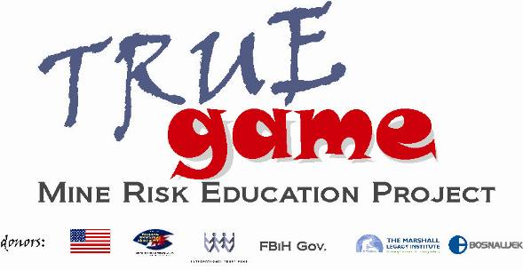

1st Bulletin
Sport Hall “Ramiz Salčin”, Mojmilo
Sarajevo, 25th May 2012 – 27th May 2012
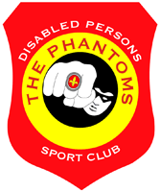
The Tournament Organiser
OKI Fantomi, Sarajevo

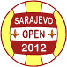 | XI International Tournament in Sitting Volleyball for Men  Sarajevo Open 2012, May 25th - May 27th 2012
The Tournament Organiser
OKI “Fantomi”, Sarajevo
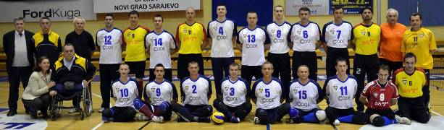
OKI “Fantomi” Sarajevo has been established in 1995 when it started its first competition season. During this period we won a number of trophies, medals and bowls in various domestic and international championships and leagues. The club OKI “Fantomi” was NATIONAL CHAMPION for five times (1996; 2002; 2006; 2008; 2009/2010), winner of B&H CUP two times (1998; 2009), winner of the EUROPEAN CHAMPION title four times (2004; 2007; 2008; 2010) and the only winner of EURO LEAGUE FOR CENTRAL EUROPE (ten times in sequence). We were also winners of tournaments “Sarajevo Open”, “Malme Open” and numerous domestic and international competitions in Leipzig, Hungary, Denmark, Croatia...
The club works a lot with young players and succeeded to completely rejuvenate the team. This is a real guarantee that this club will continue to achieve top results in sitting volleyball.
In addition, the club is involved in numerous activities aimed to help persons with a disability caused by mines and unexploded ordnance in their socio-economic rehabilitation and reintegration. An example of such activities is the project of Mine Risk Education for children that we implement together with Mine Detection Dog Centre in Bosnia and Herzegovina –MDDC.
The tournament sponsors:




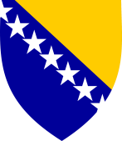




XI International Tournament in Sitting Volleyball for Men
Sarajevo Open 2012, May 25th - May 27th 2012
Although the war in Bosnia and Herzegovina is behind us, mine contamination is still a huge threat to the security of its inhabitants, and an obstacle to the development of communities affected by mines.
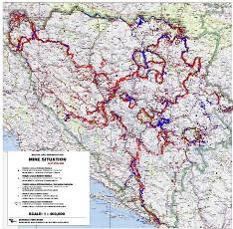
Bosnia and Herzegovina is one of the most mine-contaminated countries in the world, with more than 900,000 people living in 1,600 directly affected communities. Since 1996, landmine explosions have injured or killed 1673 individuals, taking the lives of 586 men, women, and children. Only in 2012, there are three mine victims with deadly outcome. The size of the mine suspected area in Bosnia and Herzegovina is 1340 square kilometres of land, which is total of 2,6% of the total surface of B&H. It is defined that 10407 micro locations are mine suspected, with estimated 210.000 of mines/unexploded ordnance.
In cooperation with Mine Detection Dog Centre in Bosnia and Herzegovina -MDDC, who is a creator and implementer of the project of Mine Risk Education for children in sports clubs all over Bosnia and Herzegovina, the Sitting Volleyball Club Fantomi implements the project in towns and villages of Bosnia and Herzegovina, spreading the mine awareness lessons to children age 9 to 13, teaching them how to protect themselves from becoming a mine victim. This long-lasting problem of mine contamination need to be addressed in many ways, and one of them is to conduct mine risk education, to teach people living in mine contaminated communities how to live as safe as possible with landmines that affect their everyday’s lives. B&H is still considered to be one of the most mine-contaminated countries in the world, and deaths and injuries to innocent civilians in recent months are tragic reminders that landmines continue to threaten our population 16 years after the war. Mines and explosive remnants of war continue to have a significant impact on Bosnia Herzegovina, inhibiting social, economic and agricultural development, impacting natural resources, and preventing the free movement and communication of people living in communities divided by minefields. Within the project under the slogan True Game, MDDC and Fantomi have managed to reach close to one thousand children and hundred adults and spread the mine awareness messages among them. We have visited areas like Brčko, Kakanj, Mostar, Sapna, Sarajevo, Zavidovići, Maglaj...using our positive spirit and Fantomi as an example of the courage and athleticism. This valuable project is one of a kind and links sports, health and safe behaviour to promote mine awareness among our youngest. This project is funded by a number of donors: US Department of State's Office of Weapons Removal and Abatement, ITF Enhancing Human Security, Government of Federation of B&H, Bosnalijek and Marshall Legacy Institute.
The tournament sponsors:


XI International Tournament in Sitting Volleyball for Men
Sarajevo Open 2012, May 25th - May 27th 2012
The host city
Sarajevo
Sarajevo is the capital of Bosnia and Herzegovina and is the biggest urban, cultural, economic and traffic centre of the country, the capital of the Federation of Bosnia and Herzegovina and headquarters of the Sarajevo Canton.
Urban picture of the city is characterized by a number of sacral buildings, unique mosques from Ottoman’s period, catholic and orthodox churches, synagogues and other numerous tracks of multiethnic living in the heart of the city itself.
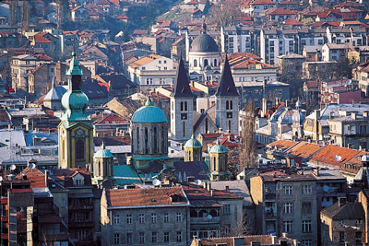
Sarajevo is the city of turbulent history that has very often influenced on global events. So, in 1914 Austrian-Hungarian crown prince Franz Ferdinand was killed and that was a cause for the beginning of the First World War; seventy years later, i.e. in 1984, XIV Winter Olympic Games, games of messages of sport, peace and friendship were held in this city. During early 1990s the name of Sarajevo was in headlines of world newspapers, because here in the heart of Europe, one of the bloodiest wars in recent European and world history happened.
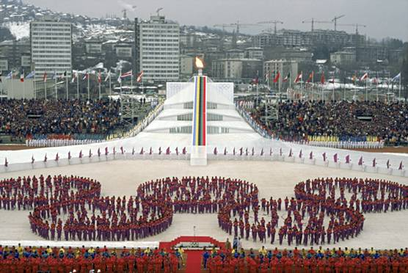
Sarajevo can be proud of well preserved old trade part of city, famous Baščaršija, coming from Ottoman's period in Bosnia and Herzegovina. This part of the city has numerous architectonic buildings of Ottoman's culture, among these there are mosques and traditional forms of oriental architecture like: old doss houses and besistans.
The tournament sponsors:



XI International Tournament in Sitting Volleyball for Men
Sarajevo Open 2012, May 25th - May 27th 2012
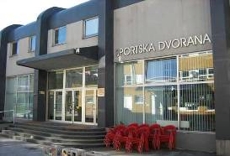
The Venue
Sport Hall “Ramiz Salčin”, Mojmilo
Competition will be held in the Sport Hall “Ramiz Salčin”, in the Olympic urban part Mojmilo. It is very near the city centre and is linked with it by public traffic.
The venue will be the central court for playing matches. Floor is parquet. Beside the playing court there is also training court.
Access to all playing and training courts, dressing rooms and other associated parts is adjusted for persons using wheelchairs.

Sport Hall is of 1000 seats for audience. Each of four separated dressing rooms is of appropriate size and comfortable, meeting all teams’ needs.
Also, beside VIP room this Sport Hall is equipped by platform for video recording of matches.
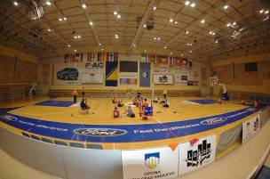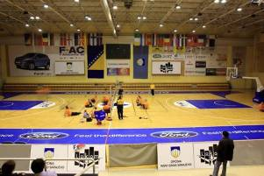
The tournament sponsors:
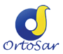

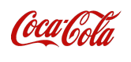

XI International Tournament in Sitting Volleyball for Men
Sarajevo Open 2012, May 25th - May 27th 2012
Accommodation
Hotel-camp “Oaza”, Ilidža
All teams will have an accommodation in luxury Hotel-camp “Oaza” in Ilidža.
Hotel is located about 20 minutes drive from the Sport Hall and about 15 minutes from the International Airport Sarajevo.
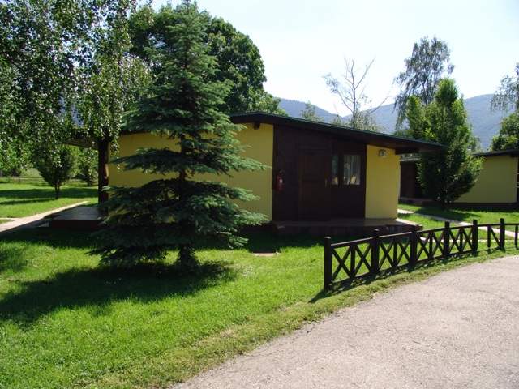
It is surrounded by beautiful parks and is located in the vicinity of popular picnic place Vrelo Bosne (Well of the River Bosnia). This hotel is modern equipped and with kind hotel staff it is an ideal place for relaxation and spending nice time.
Food: Three daily meals will be served in the hotel restaurant. All teams will receive vouchers for meals. Meal time will be adjusted to schedule of playing matches and obligations of teams.
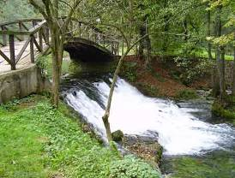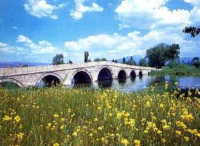
The main part of the menu is specialities of Bosnian kitchen, with possibility of alternatives of Mediterranean kitchen. In case when meals cannot be served in the hotel restaurant, the Organiser will provide lunch-packages for participants.
The tournament sponsors:




XI International Tournament in Sitting Volleyball for Men
Sarajevo Open 2012, May 25th - May 27th 2012
The Tournament Protocol

Agenda:
• Technical meeting – Hotel ''OAZA'' - Ilidža
May 25th 2012 – 22:00 p.m.
• Opening ceremony – Sport Hall ''Ramiz Salčin'' - Mojmilo
May 26th 2012 – 09:30 a.m.
• Competition start – Sport Hall ''Ramiz Salčin'' - Mojmilo
May 26th 2012 – 10:00 a.m.
• Semi-final match
May 26th 2012 – 17:00 p.m.
• Cocktail ''Fantomi Evening'' – Hotel ''Austria'' (Ilidža)
May 26th 2012 – 20:00 p.m.
• Matches for places from 5th to 8th
May 27th 2012 – 09:30 -11:00 a.m.
• Match for 3rd place
May 27th 2012 – 11:00 a.m.
• Final match
May 27th 2012 – 13:00 p.m.
• Closing ceremony
May 27th 2012 – 14:30 p.m.
The tournament sponsors:



XI International Tournament in Sitting Volleyball for Men
Sarajevo Open 2012, May 25th - May 27th 2012
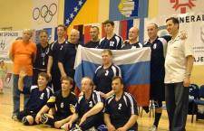  Russia National team | 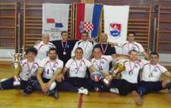  IOK Zagreb
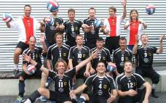  TSV Bayer 04 Leverkusen | 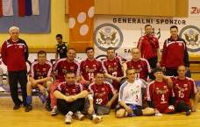  Start Wroclaw
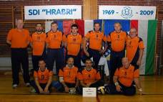  SDI Hrabri | 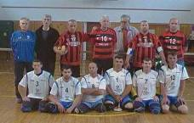  Grad Zenica
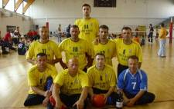  OKI Ilidža | 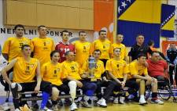  OKI Fantomi

XI International Tournament in Sitting Volleyball for Men
Sarajevo Open 2012, May 25th - May 27th 2012
Sarajevo Open 2012
PARTICIPATING TEAMS - GROUPS
 | GROUP „A“ |  | GROUP „B“
1 | RUSSIA National team (RUS) | 1 | IOK‘’ZAGREB’’(CRO)
2 | TSV ‘’BAYER 04’’LEVERKUSEN (GER) | 2 | ‘’START’’ (POL)
3 | SDI ''HRABRI'' (CRO) | 3 | ‘’GRAD ZENICA’’ B&H
4 | OKI’’ILIDŽA’’ B&H | 4 | OKI ''FANTOMI'' SARAJEVO B&H

SCHEDULE & SCORES
Group competition
(group matches are played over wining two sets)
Match No | Date | Time | Court | Team | I | II | III | IV | V | Score
1 | Saturday | 10,00 | A | RUSSIA
 | 26.05.2012 |  |  | HRABRI

Match No | Date | Time | Court | Team | I | II | III | IV | V | Score
2 | Saturday |  | B | FANTOMI
 | 26.05.2012 |  |  | START

Match No | Date | Time | Court | Team | I | II | III | IV | V | Score
3 | Saturday |  | A | BAYER 04
 | 26.05.2012 |  |  | ILIDŽA

Match No | Date | Time | Court | Team | I | II | III | IV | V | Score
4 | Saturday |  | B | ZENICA
 | 26.05.2012 |  |  | ZAGREB

XI International Tournament in Sitting Volleyball for Men
Sarajevo Open 2012, May 25th - May 27th 2012
Match No | Date | Time | Court | Team | I | II | III | IV | V | Score
5 | Saturday |  | A | RUSSIA
 | 26.05.2012 |  |  | ILIDŽA

Match No | Date | Time | Court | Team | I | II | III | IV | V | Score
6 | Saturday |  | B | ZENICA
 | 26.05.2012 |  |  | FANTOMI

Match No | Date | Time | Court | Team | I | II | III | IV | V | Score
7 | Saturday |  | A | BAYER 04
 | 26.05.2012 |  |  | HRABRI

Match No | Date | Time | Court | Team | I | II | III | IV | V | Score
8 | Saturday |  | B | ZAGREB
 | 26.05.2012 |  |  | START

Match No | Date | Time | Court | Team | I | II | III | IV | V | Score
9 | Saturday |  | A | RUSSIA
 | 26.05.2012 |  |  | BAYER 04

Match No | Date | Time | Court | Team | I | II | III | IV | V | Score
10 | Saturday |  | B | FANTOMI
 | 26.05.2012 |  |  | ZAGREB

Match No | Date | Time | Court | Team | I | II | III | IV | V | Score
11 | Saturday |  | A | ILIDŽA
 | 26.05.2012 |  |  | HRABRI

Match No | Date | Time | Court | Team | I | II | III | IV | V | Score
12 | Saturday |  | B | ZENICA
 | 26.05.2012 |  |  | START

XI International Tournament in Sitting Volleyball for Men
Sarajevo Open 2012, May 25th - May 27th 2012
Semi-finals
(matches are played over wining three sets)
Match No | Date | Time | Court | Team | I | II | III | IV | V | Score
13 | Saturday | 17:00 | A | A1
 | 26.05.2012 |  |  | B2

Match No | Date | Time | Court |  | I | II | III | IV | V | Score
14 | Saturday | 17:00 | B | B1
 | 26.05.2012 |  |  | A2

Match for 7th and 8th place
Match No | Date | Time | Court | Team | I | II | III | IV | V | Score
15 | Sunday | 9:30 | A | A4
 | 27.05.2012 |  |  | B4

Match for 5th and 6th place
Match No | Date | Time | Court |  | I | II | III | IV | V | Score
16 | Sunday | 9:30 | B | A3
 | 27.05.2012 |  |  | B3

Bronze medal
(match is played over wining three sets)
Match No | Date | Time | Court |  | I | II | III | IV | V | Score
17 | Sunday | 11:00 | A | L 15
 | 27.05.2012 |  |  | L 16

FINALE
(match is played over wining three sets)
Match No | Date | Time | Court |  | I | II | III | IV | V | Score
18 | Sunday | 13:00 | A | W 15
 | 27.05.2012 |  |  | W 16

XI International Tournament in Sitting Volleyball for Men
Sarajevo Open 2012, May 25th - May 27th 2012
