 

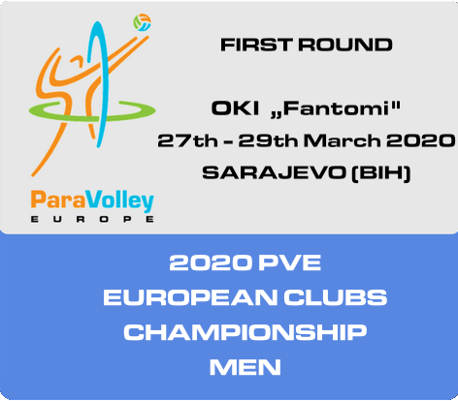

WELCOME MANUAL

# Dear friends,

We are happy to see you again in Bosnia and Herzegovina on our 2020 European Clubs Championship – First Round, Men, **Pool A.**

We will do our best to make you feel good and compete the best you can in Sarajevo.

Looking forward to see you soon!

Kind regards,

Mirsad Mirojević, Manager

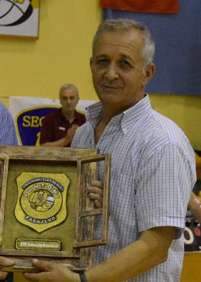

# Organization committee, responsibility

The main Organizer: **Pool A**

**U OKI ‘’FANTOMI’’ Sarajevo, St. Semira Frašte br.11, Bosnia and Herzegovina, e-mail :** [**oki.fantomi@gmail.com**](mailto:oki.fantomi@gmail.com)

**Manager Mirsad Mirojević, e-mail** : [oki.fantomi@gmail.com](mailto:oki.fantomi@gmail.com)**, GSM : + 387 61 552 708** **Person responsible for communication with PVE Communication Director: Mirza Mršo**

|  |  |  |  |
| --- | --- | --- | --- |
| Name | Country | Function | Arrival/Departure |
| Travel costs, accommodation and per diems to be paid by the host | | | |
| Jan van de Wijngaard | NED | PVE/Technical Delegate | TBC |
| Adnan Kološ | BIH | PVE/Referee | TBC |
| Travel costs, accommodation to be paid by participating Club Team; per diems to be paid by PVE | | | |
| Haris Helač | BIH | WPV Referee | TBC (SPID) |
| Ema Vratarič | SLO | WPV Referee | TBC (OK Šempeter) |
| Edin Begović | BIH | WPV Referee | TBC ((KDZ Eregli) |
| Christian Battisti | BIH | WPV Referee | TBC (SVR Fonte Roma Eur) |

Organizer of the competition -

**Mirsad Mirojević. e-mail :** [**oki.fantomi@gmail.com**](mailto:oki.fantomi@gmail.com)**,** **GSM : +387 61 552 708**

# Transport

Transport from/to the airport will be organized by buses. The official airport is the airport **Sarajevo.** The member of the Organizing committee will meet participating teams at the airport. Schedule of transport will be agreed with teams.

For participating teams that will travel by own buses we provide the following information:

Accommodation: Hotel Imzit Dobrinja; Hotel Hollywood Ilidža; : 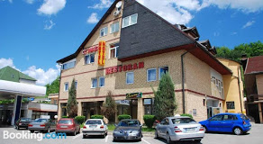 

Address: Lukavička Cesta, Sarajevo 71000 St. Dr. Mustafe Pintola 23, Ilidža 71210

Phone: +387 (0) 33 451-423 Phone: + 387 (0) 33 773-100

Sport hall: SD ‘’RAMIZ SALČIN’’ MOJMILO St. Semira Frašte close to No.11;

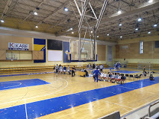 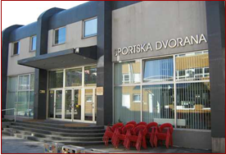

# Meals

Three meals a day (breakfast, lunch, dinner). Food will be provided in the hotel and sport hall.

Meal times:

Breakfast: 07:30 a.m.; Lunch: 13:00 p.m. - 15:00 p.m. and dinner: 18:30 p.m. - 21:00 p.m.

The Organizer will provide bottled water. Schedule of meals will be adjusted to the schedule of playing matches.

# System and schedule of competition

The following 5 teams will participate in 2020 European Clubs Championship - First Round, Men, **Pool A**  **:**

**A1 OKI Fantomi B&H**

**A2 SVR Fonte Roma Eur ITA**

**A3 KDZ EREGLI TUR**

**A4 Odbojkarsko društvo Šempeter SLO**

**A5 SDI SPID B&H**

|  |  |  |  |  |  |
| --- | --- | --- | --- | --- | --- |
|  |  |  |  |  |  |

2020 PVE Clubs Championship Regulations will apply on this competition, including Appendix A.

## SCHEDULE

**Friday, 27 March 2020,**

Arrival of ITOs and teams no later than 16:00 p.m.

|  |  |  |
| --- | --- | --- |
| SATURDAY,  28 03 2020 | 1. 09:00 a.m | OKI Fantomi (B&H) - Odbojkarsko društvo Šempeter (SLO) |
| 2. 10-30 a.m. | SVR Fonte Roma Eur (ITA) - SDI SPID (B&H) |
| 3. 12-00 p.m. | KDZ EREGLI (TUR) - Odbojkarsko društvo Šempeter (SLO) |
| 4. 13-30 p.m. | SDI SPID (B&H) - KDZ EREGLI (TUR) |
| 5. 15:00 p.m. | OKI Fantomi (B&H) - SVR Fonte Roma Eur (ITA) |
| 6. 16.30 p.m. | KDZ EREGLI (TUR) - OKI Fantomi (B&H) |
| 7. 18:00 p.m. | Odbojkarsko društvo Šempeter (SLO) - SDI SPID (B&H) |
| SUNDAY,  29 03 2020 | 8. 09:00 a.m. | SVR Fonte Roma Eur (ITA) - KDZ EREGLI (TUR) |
| 9. 10:30 a.m. | Odbojkarsko društvo Šempeter (SLO) - SVR Fonte Roma Eur (ITA) |
| 10. 12:00 p.m. | SDI SPID (B&H) - OKI Fantomi (B&H) |

PRELIMINARY INQUIRES before each match

**The following documents are to be controlled:**

ID cards / passports of the players

APPROVED PVE Team Licence

Form C-2 “Final team registration”

# Communication

Hashtag to use throughout competition:

* + #ClubsSittingVolleyball